

**Student and Family Toolkit**

© 2012 EDMENTUM, INC.

Student and Family

Welcome

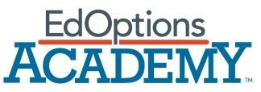

Welcome to the EdOptions Academy! The Academy is committed to meeting your diverse needs and helping you to successfully complete your virtual programs. This toolkit will provide you with the resources and information that you'll need to begin learning online with EdOptions Academy. Taking full advantage of these resources will help ensure your success.

Student Orientation Overview

This toolkit will help you use the features of EdOptions Academy’s Student Information System (SIS). You’ll learn how to access different online assignments and how to participate in open-ended discussions with other students assigned to your teacher. This toolkit will also help you understand your responsibilities as an online student in the EdOptions Academy.

Student Responsibilities

As a student, you have these responsibilities:

1. Follow the Student Code of Conduct. This information is emailed to all students upon registration in the EdOptions Academy. You are responsible for reading the Student Code of Conduct and contacting your Site Coordinator with any questions. By electronically signing the Student Code of Conduct and emailing it to your teacher, you agree to adhere to it.

1. Read the Student Policy Guide. This document details what you must do to successfully complete courses in the EdOptions Academy.

1. Stay on track with your assigned classes. Your teacher will help you monitor your pace in a class, but make sure youcomplete assignments on time and to the best of your abilities.
   * Fall and Spring Session classes are one semester, or 18 weeks. You are expected to spend 50 minutes a day on each class, 5 days a week.
   * Summer Session classes are 8 weeks. Class content is not condensed; instead, the amount of class time each day is increased to accommodate the condensed time frame. You are expected to study 4 hours per day, 5 days a week.

1. Stay in contact with your teachers. You can email your EdOptions Academy Teacher directly from the Learning Management System or Student Information System.

1. Stay in contact with your Site Coordinator, the person at your school who is in charge of the EdOptions Academy. If you need to drop a class or need more time to complete a class, contact your Site Coordinator.



© 2012 EDMENTUM, INC.

Logging In

You will receive your log-in information in an email after you are registered in the EdOptions Academy.

# How to Log In

Go to this site: [http://academy.platoweb.com](http://academy.platoweb.com/)

Enter the following information: • Your account login

• Your password

# Forget your Login and/or Password?

If you ever forget your log-in information, follow the directions on the log-in page to retrieve your password or login.

EdOptions Academy Student Information System (SIS)

# Dashboard

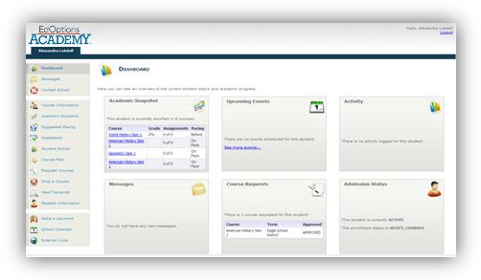

The Dashboard (shown above) serves as your home page for the EdOptions Academy Student Information System (SIS). You can see snapshots of the classes you are enrolled in, any upcoming events, student activity, messages received, current class requests, and your admission status. On the left is a list of additional links that are available regardless of which page you are on in the SIS. At any time, you can return to the home page by clicking on the Dashboard at the top of this list.

# Messages

There are two ways to view your messages. On the bottom left of your home page (shown below) you will be notified how many new messages you have when you log in. Click the “See your messages…” link to go to the messages page. You can also access the messages page by clicking Messages on the left side of the screen.

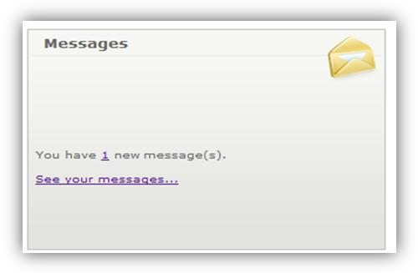

Click “Create new messages” to send a message. From the drop-down menu options, you can choose the person you want to send a message to, as well as the message’s level of priority. There are several tools available for you to customize and format any message you send.

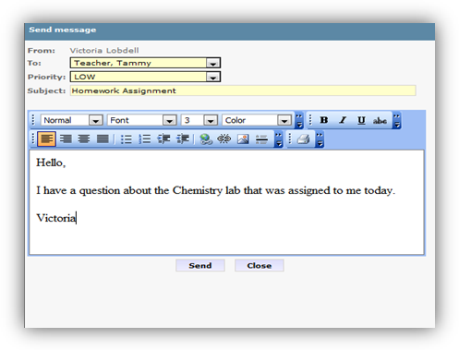

# Class Information

Select Course Information on the left side of the page to see information about both the class and your teacher. You will see the class length, the number of credits the class is worth, upcoming events, and teacher contact information.

# Academic Snapshot

This page allows you to see the status and academic progress for the classes you are enrolled in. You will see the following information for each class:

* Enrollment date
* Grade
* Assignments
* Pacing
* Last Activity

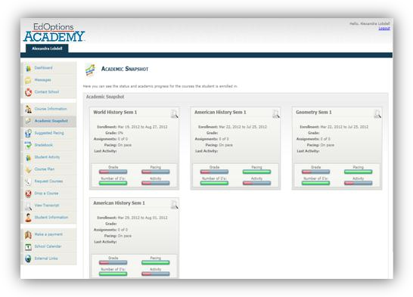

# Suggested Pacing

Here you will be able to quickly see how many assignments you will need to complete each week in order to finish the class on time. This page shows the weeks, the number of original assignments per week, and any extra assignments. You can view the suggested pacing for each class by clicking on the class name at the top of the page.

# Gradebook

Your grades are easily accessible on the Dashboard. To view a detailed summary for each class, click Gradebook on the left side of the screen. Scroll through each class to see information about assignments and earned grades.

# Transcripts

To access your transcript, click View Transcript on the left side of the screen. You’ll see an unofficial transcript that states your cumulative credits, weighted GPA, and unweighted GPA. Official transcripts with a raised seal are available upon request.

# Accessing Your Classes

In the SIS, you can select your assigned classes in several different ways. Under the Course Information tab, click “Go to course” to access each class. Your classes are also listed in the Academic Snapshot located on the Dashboard. Clicking the title of the class will take you directly to your assignments.

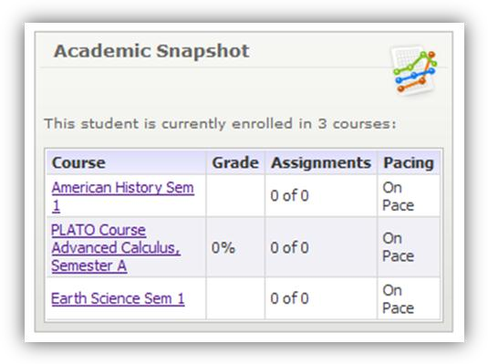

Class Structure

# Tutorials

Tutorials are modules with direct instruction and practice interactions. The instruction includes videos, animations, interactive timelines, and hotspot graphics. Tutorials also have a number of practice interactions such as drag-and-drops, ordered problem solvers, multiple-choice questions, and fill-in-the blank questions that will help you check your progress at mastering new concepts. Some tutorials also include Web links to informational sites, games, and videos to broaden your access to information on the topic.

# Assignments

EdOptions Academy’s learning environment provides a number of online activities to enhance your learning experience and to make it more interactive. You will have two types of assignments—drop box activities and discussions. Your teacher makes both of these assignments. They can be either graded or non-graded.

# Drop Box (graded)

A drop box activity allows you to upload files for a completed assignment. Your teacher will then review and grade your work.

# Online Discussions

# (section and threaded)

A discussion is an activity your teacher assigns to ask complex, open-ended questions. These discussions will encourage you to reflect on concepts, articulate your thoughts, and respond to the views of others. You will need to use critical thinking skills to respond to these questions.

Discussions can be section discussions or threaded discussion. Section discussions are not graded. You will reply to an open-ended question and can respond to the replies of other students. Threaded discussions, on the other hand, are graded discussions. Your teacher will grade you on all the replies you have submitted.

# End-of-Semester Tests

End-of-semester (EOS) tests are locked in the EdOptions Academy Student Information System and can be unlocked only by your Site Coordinator. EOS tests require proctoring. Work with your Site Coordinator to set up a time and location for you to complete the test.

# Class Completion

Contact your teacher and Site Coordinator when you are nearing completion of a class. They will help you with the next steps. Also contact them if you are having trouble completing a class during the semester.

|  |
| --- |
| Contact your EdOptions Academy teacher or Site Coordinator first with any ques tions.  You can also call **1-866-890** **8153** for additional support. |

Setting up Your Work Station

Pop-up blockers must be disabled or configured properly in order to run PLATO courseware successfully. Pop-up blockers or stoppers are used to prevent additional windows, typically advertisements, from opening within a Web browser. Pop-up blocking software disables JavaScript™ pop-up ads, but it also disables legitimate site functionality using JavaScript™. The procedures to disable or configure pop-up blockers vary, depending on the software used. Assistance with configuring the settings should be available within the pop-up blocker application.

Click [here](https://support.plato.com/Site_Resources/Landing_Pages/Technical) for more help with getting your work station ready for the EdOptions Academy.

Parent and Guardian Overview

You should have received your login and password in a Welcome email. If you did not receive a login, please contact your student’s Site Coordinator.

Please read through this entire toolkit carefully so that you are able to support your student. You have access to many of the same tools in the EdOptions Academy Student Information System (SIS) described in the student portion of this toolkit.

# Monitoring Your Student

You can view the classes your student is currently enrolled in by logging into the SIS. Once logged in, you can monitor the student’s progress and performance and contact the teacher for each class right from the Dashboard.

# Communication

Through the SIS, you can email teachers directly with questions at any time. Teachers are there to support both you and your student. They will respond within 24 hours on school days. However, please note that you will not always be copied on emails that teachers send to students about their day-to-day progress.

You and your student also have the opportunity to connect with your EdOptions Academy teachers and administrators through [Skype.](http://redirect.platoweb.com/345320)

# Parent/Guardian Support

If you need support for a student’s specific class, please contact the teacher directly. The teacher’s contact information can be found under Course Information.

If you need support for any issue or topic not related to a specific class, please contact the Program Manager by email at support.academy@plato.com or call **1-866890-8153.**